10 Baking Basics #1 Food, Nutrition & Wellness Chapter 32 & 34 /96 Name: __________________
- What are the 8 basic ingredients in baked products and briefly describe their function in baked products (16)

- Describe the difference between batter and dough (2).

- What are the three common leavening agents in baked goods? (3)

- Why is it important to use the correct size pan? (2)

- Why is it important to use the correct oven temperature? (2)
- Explain the difference between Quick Breads and Yeast Breads. (2) Give an example of each type of bread (2).

- What are the three steps of the muffin method? (3)

- What are the three steps of the biscuit method? (3)

- What are the 6 types of cookies – give a brief description of each and an example. (18)

- What are the 3 types of cakes? (3)
- A shortened cake contains _______. They are leavened with _______ ________ or _______ _______. A foam cakes is leavened from the air from beating __________ __________. A ___________ ____________ is a cross between a shortened and foam cake. It is leavened with beaten _________ _________ and __________ _________. (7)
- A __________ ________ are baked in round square or rectangle pans. A _____________ ________ is baked in a _________ pan. (3)
- What does a quality cake look like? (3)

- Describe how you know when a cake is done. (1)

Read the following statements about cookies. Write TRUE or FALSE for each statement. (12)
- ________ All cookies contain similar ingredients. How cookies are shaped makes the different kinds.
- ________ Rolled cookies are made from stiff dough.
- ________ Foam cakes are cooled in the pan and then flipped upside down.
- ________ Most cookies contain more fat and sugar and less liquid than cakes.
- ________Cookie sheets should be hot when cookies are placed on them for baking.
- ________ Store crisp cookies in a container with a tight fitting cover.
- ________Shortened cakes should be cooled for 1-2 minutes and then removed from pan immediately.
- ________ Most cookies freeze well.
- ________ Grease the pan for a foam cakes.
- ________ The tube in the tube pan helps bake the cake evenly.
- ________ Test refrigerator & bar cookies doneness by pressing lightly with your finger & the imprint should show lightly.
- ________ You can substitute applesauce for up to half of the butter in baking for a healthier recipe.

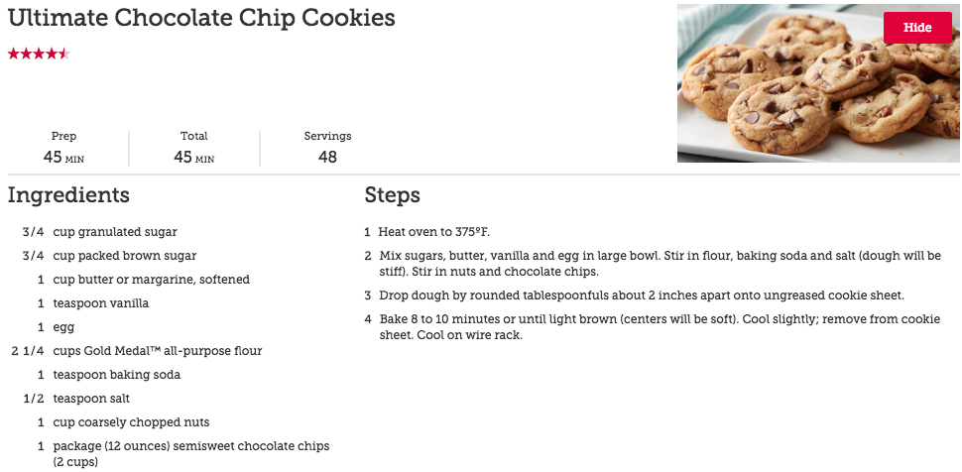
- The fat in this recipe is _____________. (1)

- The sweetener(s) in the recipe is/are _________________________________. (1)
- The leavening agent is _____________________. (1)
- What ingredients fit in the “other category” for baked goods? (3)

- Which ingredient other than fat helps make baked goods tender? _____________(1)

- What would happen if you spaced the cookie dough only 1 inch apart. (2)

- Once the cookies are baked – what should you do? (2)

- How many cookies does this recipe make? ___________ (1)
- If you decide to make 24 cookies instead – how will this affect the recipe?? (2)

